Computer Science

A2 Coursework

Callum Reid

**Evaluation**

In this document I will be evaluating to what extent I have fulfilled the user requirements of all three stakeholders. I will also be evaluating how the system works as a whole in comparison to other similar systems and I will evaluate the methods and systems used to make the system such as the IDE, database and imported libraries.

**Evaluation of programming language**

For my system I used Python version 3.8, I used this as it was the latest version available at the start of the project and it could be implemented to work well with well with MySQL and its subsequent databases. There were however some problems when it came to installing connectors for MySQL and I had to uninstall and reinstall python several times before I was able to install both the connector and the database. In my project I used python as a procedurally based programming language primarily with a small amount of object-oriented based programming for specific Tkinter widgets. This was effective as I am most comfortable with procedurally based programming and I was able to successfully utilise it to reuse code that I had previously programmed in order to streamline the coding process.

**Evaluation of programming libraries**

Listed below are all the modules that were imported for the system, several of these modules where not implemented in the final system however they remain imported as to not break any existing code that may rely on them:

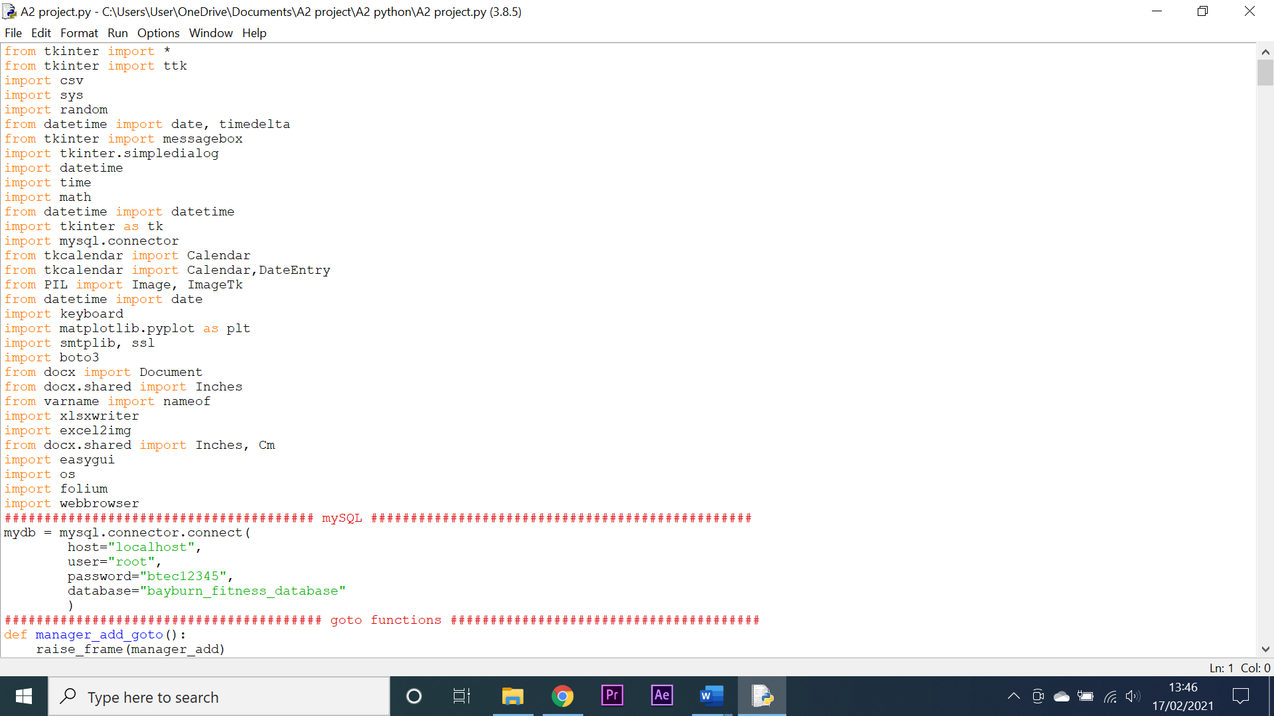

**Tkinter** – Tkinter is the library that I used to create the graphical user interface for my system. It allows for the addition of buttons, entry boxes, treeviews, labels, tick boxes and many other widgets. I used these widgets to build the user interface for my system. I was able to do find or create practically any GUI component I wanted using Tkinter however there where some problems with it: It was code-based meaning that a whole line of code had to be written to add just one component, the components had to be placed manually using trail and error with the .place() method, occasionally components would refuse to be resized or repositioned and upon updating the operating system of my computer, all the components would resize for a random amount of time. Despite all these troubles however, Tkinter was still successful at creating a working GUI for my system.

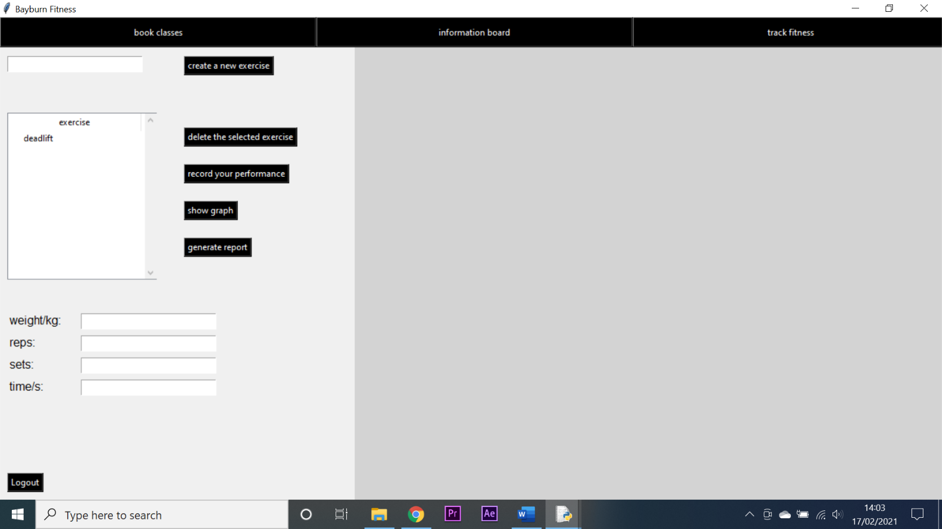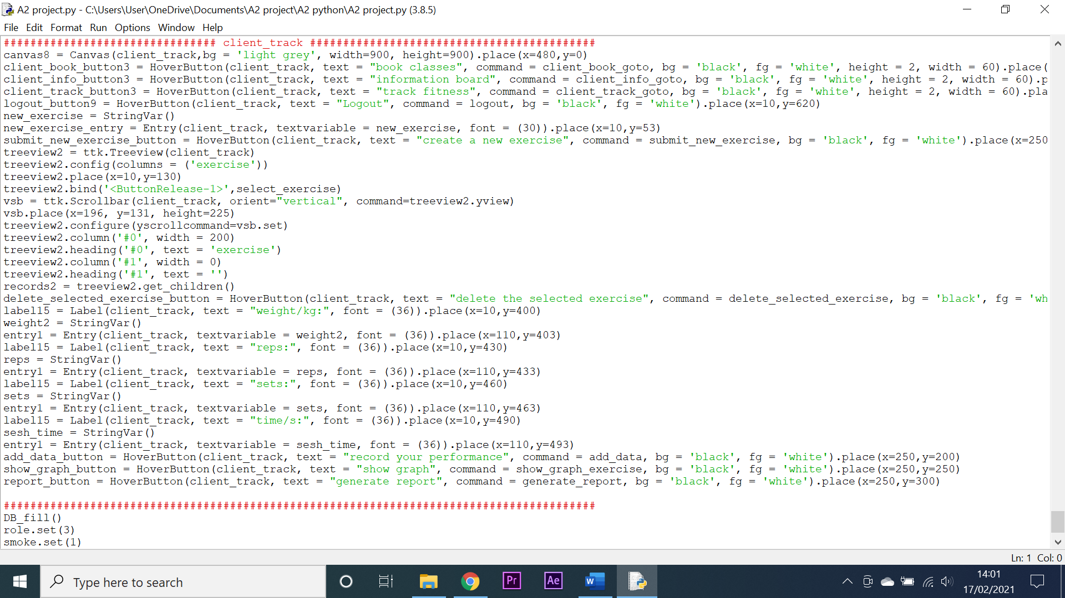

Shown above is all the code necessary for just one screen, this highlights extensive time taken for creating the GUI as opposed to implementing features for the system.

**CSV** – This module was used to created comma separated value text files. There were no noticeable problems with this module.

**SYS** – This module allows the programme to directly interact with the computer system. There were no noticeable problems with this module.

**Random** – This module allowed for the generation of random integer and float values. There were no noticeable problems with this module.

**Datetime** – This module allowed for the use of the date format in the system which allowed me to calculate dates and times for bookings. There were no noticeable problems with this module.

**Math** – This module allowed me to use complex mathematical formulas to make calculations. There were no noticeable problems with this module.

**MySQL** – This module allowed for the connection between the python programme and the MySQL database. This module was difficult to install and required the uninstalling and reinstalling of python several times before it was successfully implemented. Below is the code used to connect the system to the database.

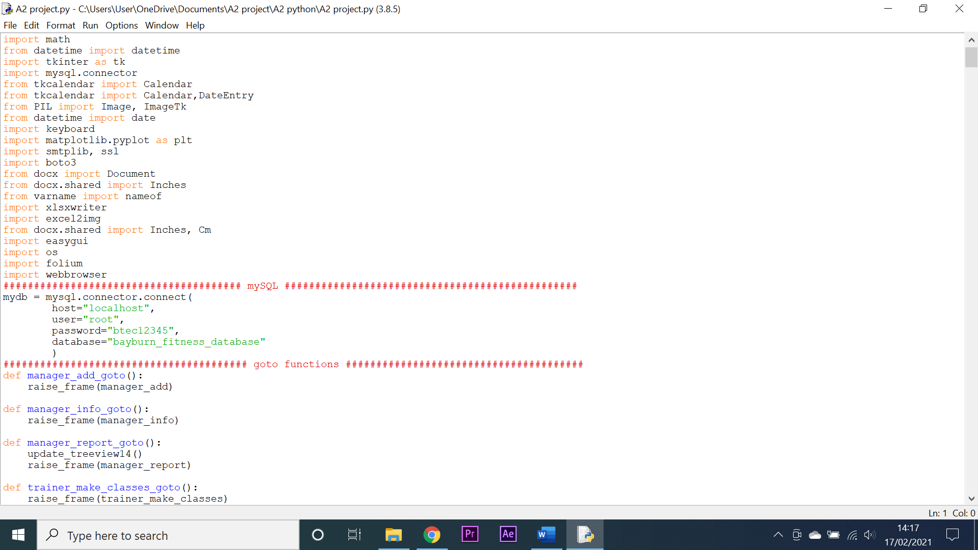

**PIL/Image** – This module allowed me to create, implement and edit image files using Python. There were no noticeable problems with this module.

**Keyboard** – This module allowed for interaction with the keyboard such as detecting keypresses. There were no noticeable problems with this module.

**Smtplib** – This module allowed for the sending of emails by the system. There were no noticeable problems with this module.

**Boto3** – This module allowed for the connection to amazon web service which in tern allowed for the sending of SMS messages. There were no noticeable problems with this module.

**Docx** – This module allowed for the creation of word documents by the system in order to generate data reports. There were no noticeable problems with this module.

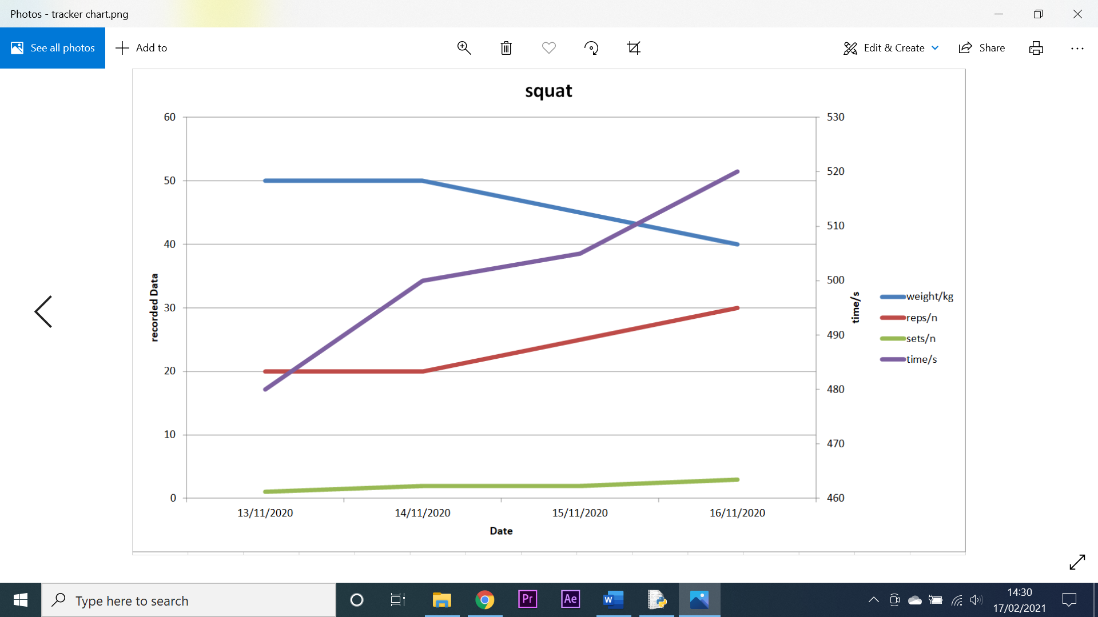**Xlsxwriter** – This module was used to generate excel files and charts within those files. The problem with this module is that it is slow and can sometimes take upwards of 30 seconds to generate a file. However, I used this over the faster graph generator (Matplotlib) as the graphs in excel look better and have better axis scaling as shown below:

**Excel2img** – This module is used to extract the chart from an excel file as an image which could then be inserted into a Tkinter interface. There was a small problem with this module when saving the image as the resolution and quality of the file was severely reduced after it was edited. This was however rectified by saving the image in a different file format.

**EasyGUI** – This module was used to create a file dialogue box which would allow the user to save reports or documents in specific files or areas on their disk. There were no noticeable problems with this module.

**OS** – This module was used for the system to interact with the computers operating system. There were no noticeable problems with this module.

**Folium** – This module allows for the creation of web based interactive maps which could be accessed by the user. There were no noticeable problems with this module.

**Webbrowser** – This module was used for the system to interact with the local web browser which was Chrome. This allowed for the web based interactive map to be s=accessed by the system. There were no noticeable problems with this module.

**Evaluation of Integrated Development environment**

Python comes with its own Integrated Development environment known as IDLE. This was the IDE that I used to programme my system in. it has several features that allow for the streamlining of any development process.

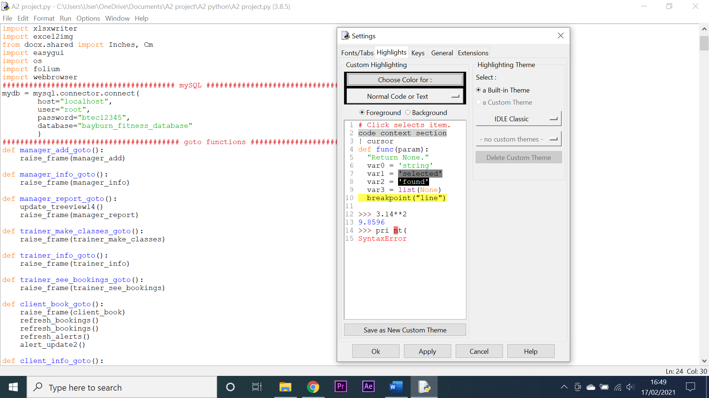**Colour coding key words** – This feature colours specific words or statements in respective colours so that the programmer can easily identify errors in code as well as differentiate between the different parts of their code. IDLE does this excellently and even provides the user with the option to customise the colour coding as they see fit. This is shown below:

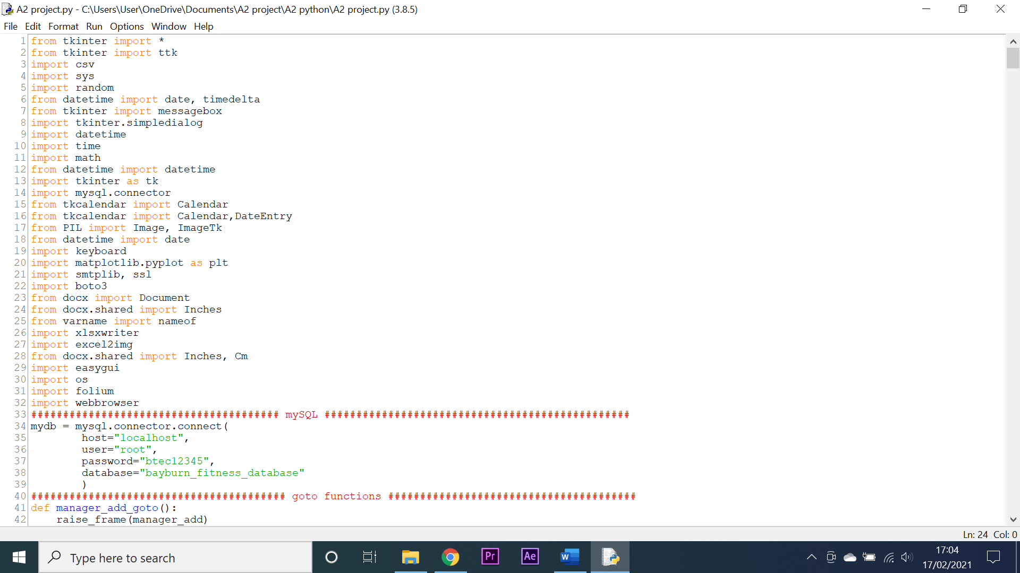**Line numbering** – This feature allows for a programmer to view what line of code they are looking at on the left-hand side of the screen. Whilst this feature is well implemented into the IDE, I seldom used it as I found no real purpose for it. The line numbering is demonstrated below:

**Breakpoints** – This feature allows a user to set breakpoints in their code. The code will run up to this marker at which point it will terminate and all variables can then be viewed by the user. This system is implemented well in IDLE as it is simple to use however, I rarely found myself using it as often times it was easier to simply print the contents of variables to the screen. The breakpoint system is demonstrated below:

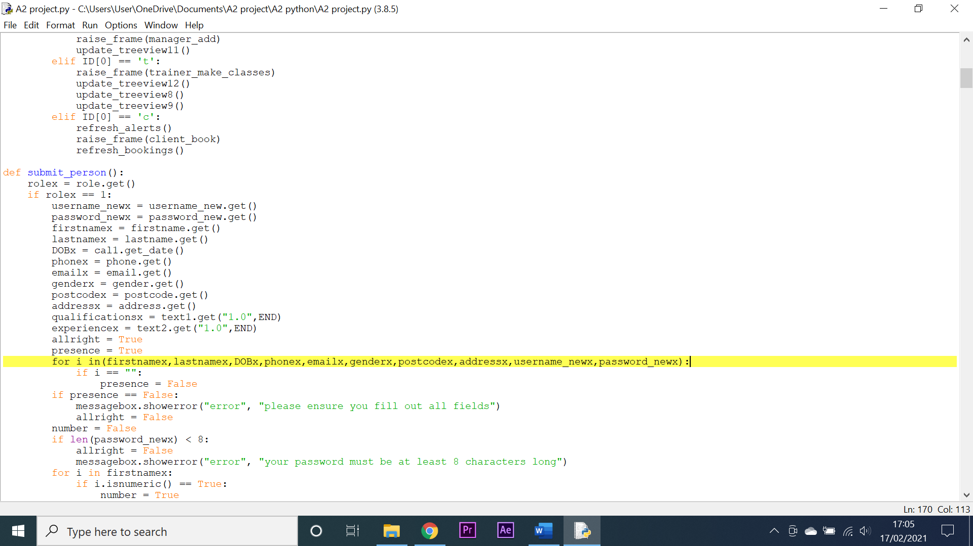

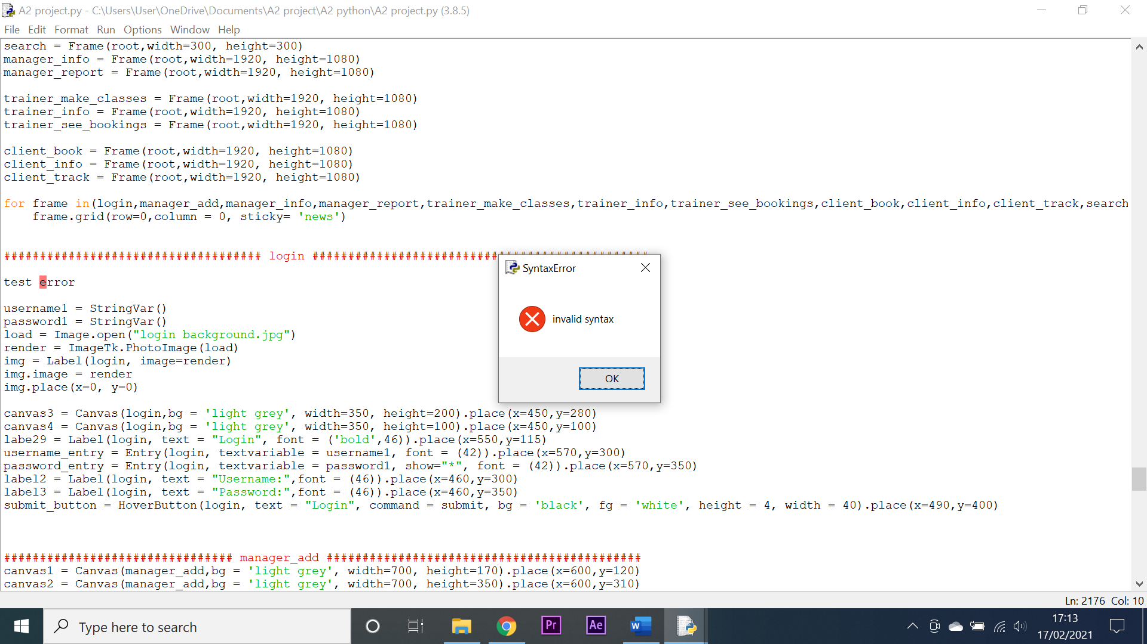**Syntax error detection** – This feature allows a syntax error to be detected before the code is fully compiled. This feature is incredibly useful as it highlights the offending code when you attempt to compile it however if there is multiple lines of syntax errors, the user must run the programme several times to find all the mistakes. The syntax error detection is demonstrated below:

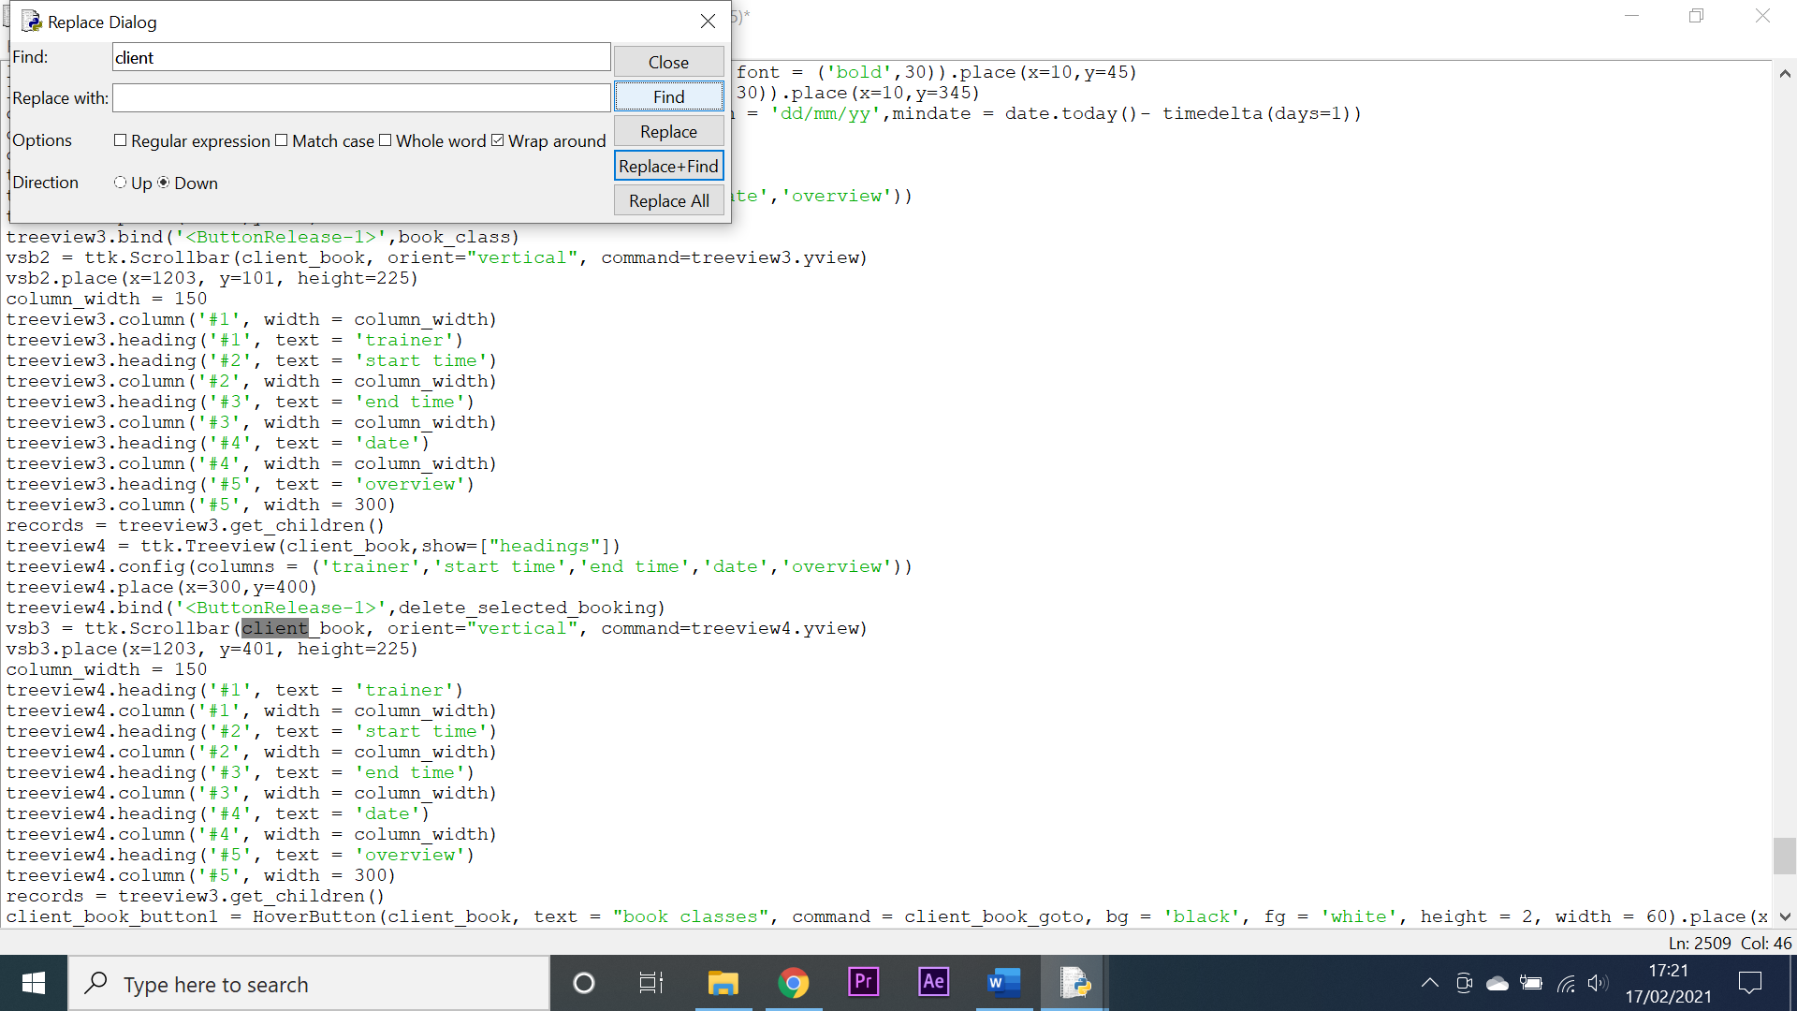**Code search feature** – This feature allows a user to search for key words or phrases and the system will redirect them to that exact line and highlight it, if there are multiple lines containing this key word or phrase the system allows the user to click the ‘find next’ button and it will redirect them to the next instance of this key. This feature works well and was especially useful towards the end of development when there was an extreme amount of code in the file and sifting through it to fix errors manually would have been challenging. The search system also allows for code to be replaced however whilst I did use it I only found a few applications for this feature and it was not used very often. Below is a demonstration of the feature:

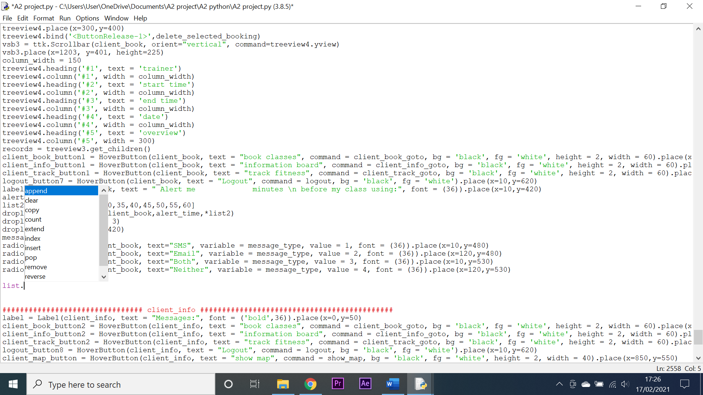**Auto completion of code** – This feature allows for an open-ended statement to be completed from a selection of options. This feature is well implemented in IDLE however I did not find a use for it as it was often easier to just type the code yourself. The feature is demonstrated below:

**Evaluation of database management**

For my project I used MySQL as it is an effective database management tool that is used by many large companies around the world. It is also free to use and integrates effectively with python using connectors. The code below shows how the python programme connects to the database:

There were however some problems when trying to install the connectors for MySQL and this resulted in me having to uninstall and reinstall python several times before I was able to connect the database to the programme.

I hosted the database on my local computer as opposed to remotely. This allowed me to have quick access to both the database and the programme at the same time however there are some drawbacks to this method:

* For larger databases this would use up a lot of CPU and memory resources that could be applied to the actual programme and a substantially larger database may not even be able to run on my computer.
* If the system were rolled out to multiple customers, it would require my computer to always be active and running in order for them to access the database.

Both of these problems could be resolved by creating a designated server that could host the database 24/7. This designated server would be designed to host a database and thus have plenty of memory and CPU resources to expend as well as being reliant and robust enough to run for long periods of time.

One final problem with the MySQL database is that I could not find an effective way of backing up the database. This hindered me when a technical fault meant I had to install a new motherboard in my computer and retrieve all my previous files from a backup.

In my database I used entirely strings as the data structure that I stored data in. I did this as it allowed me to easily manipulate data using Python’s string manipulation tools as well as easily cast data into multiple different data types such as lists or integers. The only problem I had with this was when it came to date formatting. Multiple different modules in python used different date formats and so it was at times difficult to interchange between these through string manipulation.

**Evaluation of my system in comparison to a similar one**

When evaluating my system against a similar system, I will be evaluating it against Strava and Gofyt. Strava is considered by many to be the best fitness tracking and performance apps on the market. Gofyt is a relatively new app and it is used for primarily class bookings. Both these systems are web based.

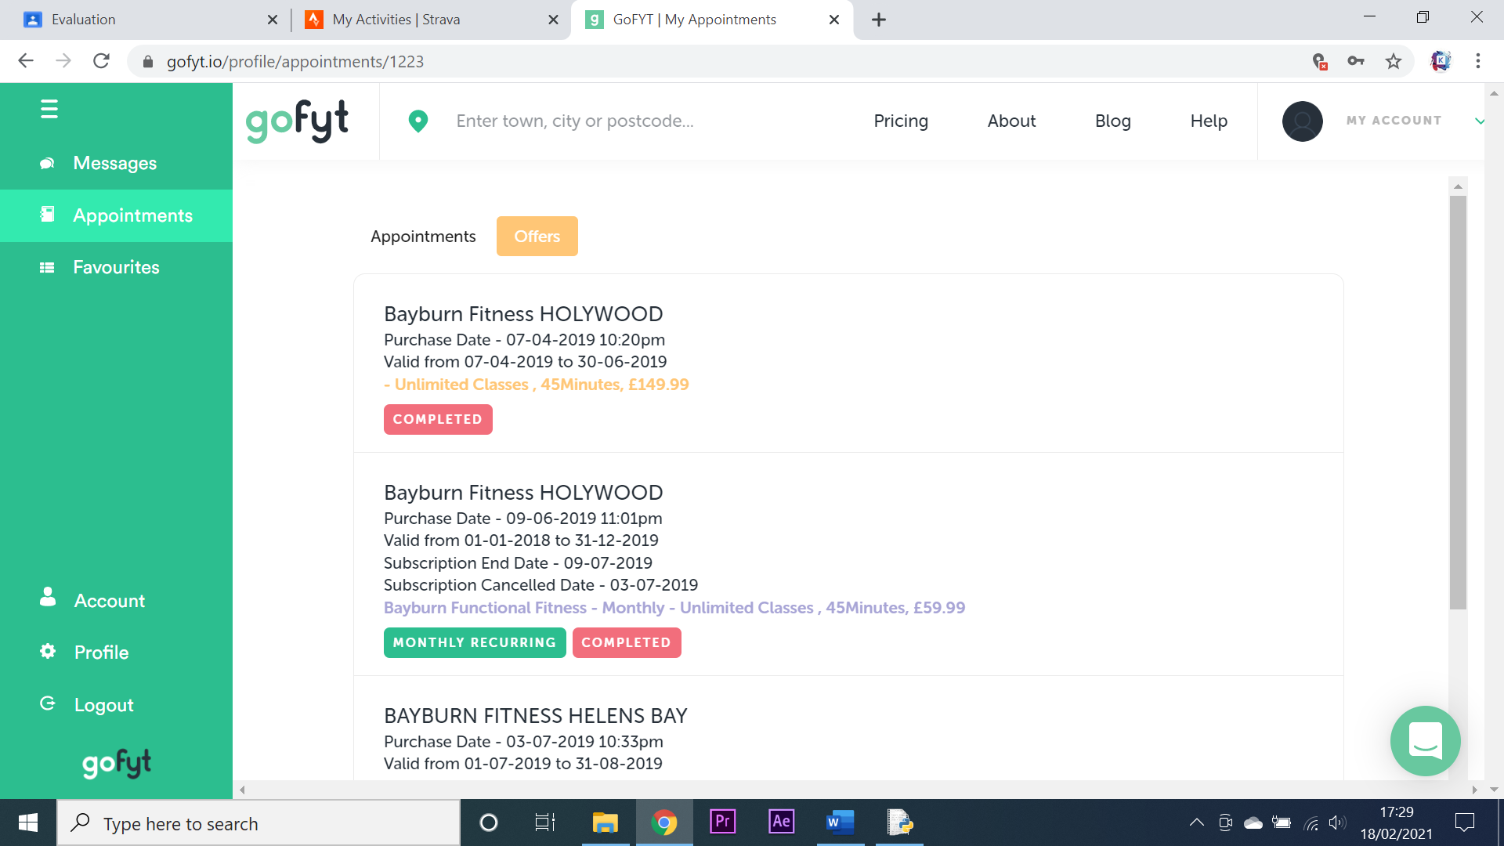**Booking classes** – Gofyt is the system that is used for booking classes. It partners with many different fitness companies to allow for bookings across multiple different services such as personal training, yoga classes and sports training. My system by contrast only allows for the booking of classes through Bayburn Fitness. This could be considered a drawback however it allows for my system to be far more specialised and accommodate for the needs of Bayburn fitness specifically. Gofyt has much the same booking system to mine as I based my booking system off of it, this means that they both have similar functionality as shown in the screenshots below:

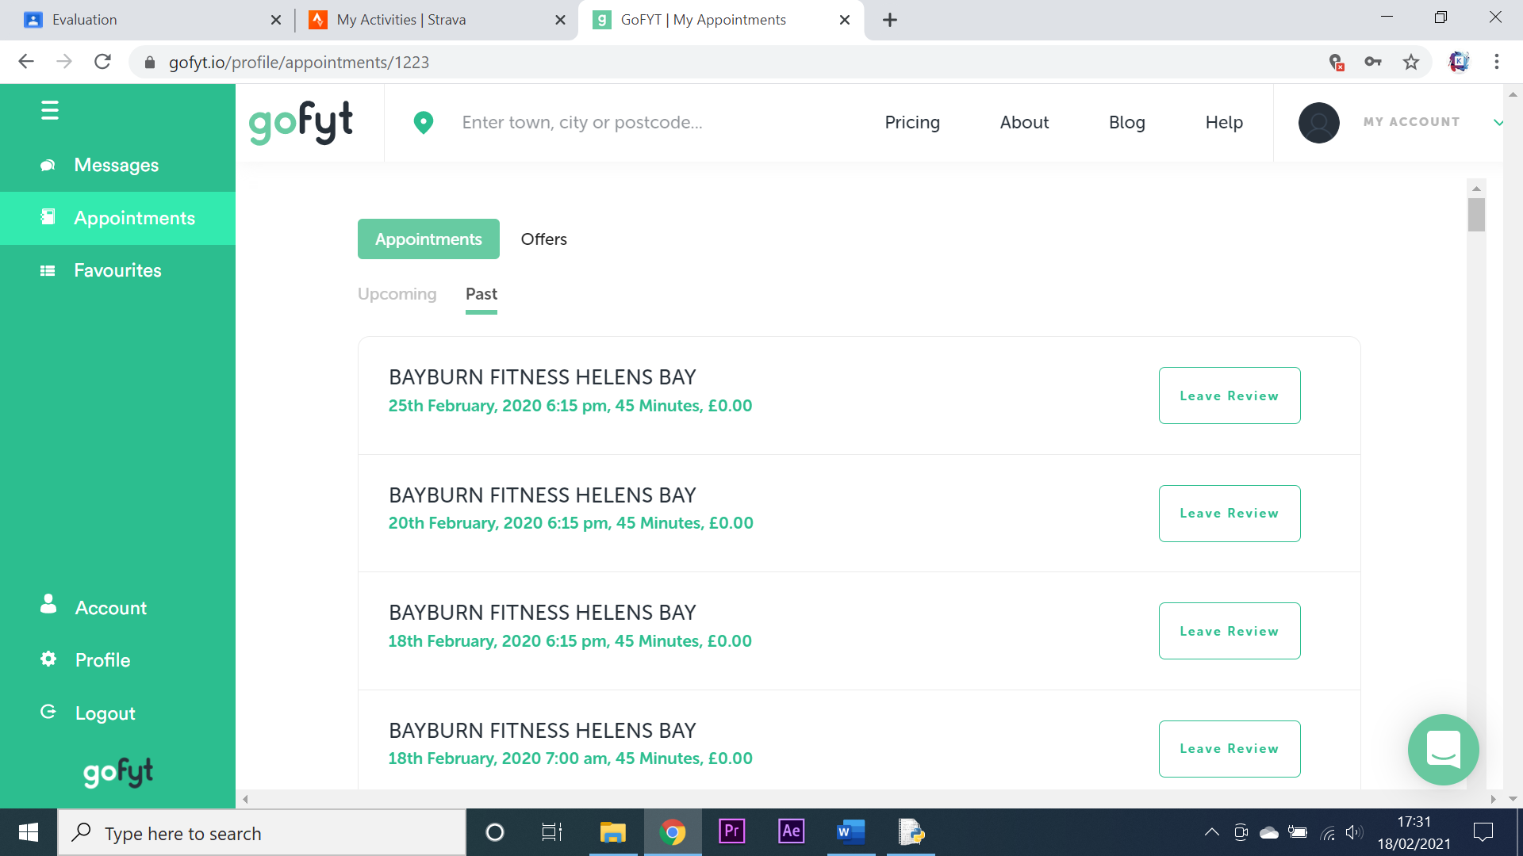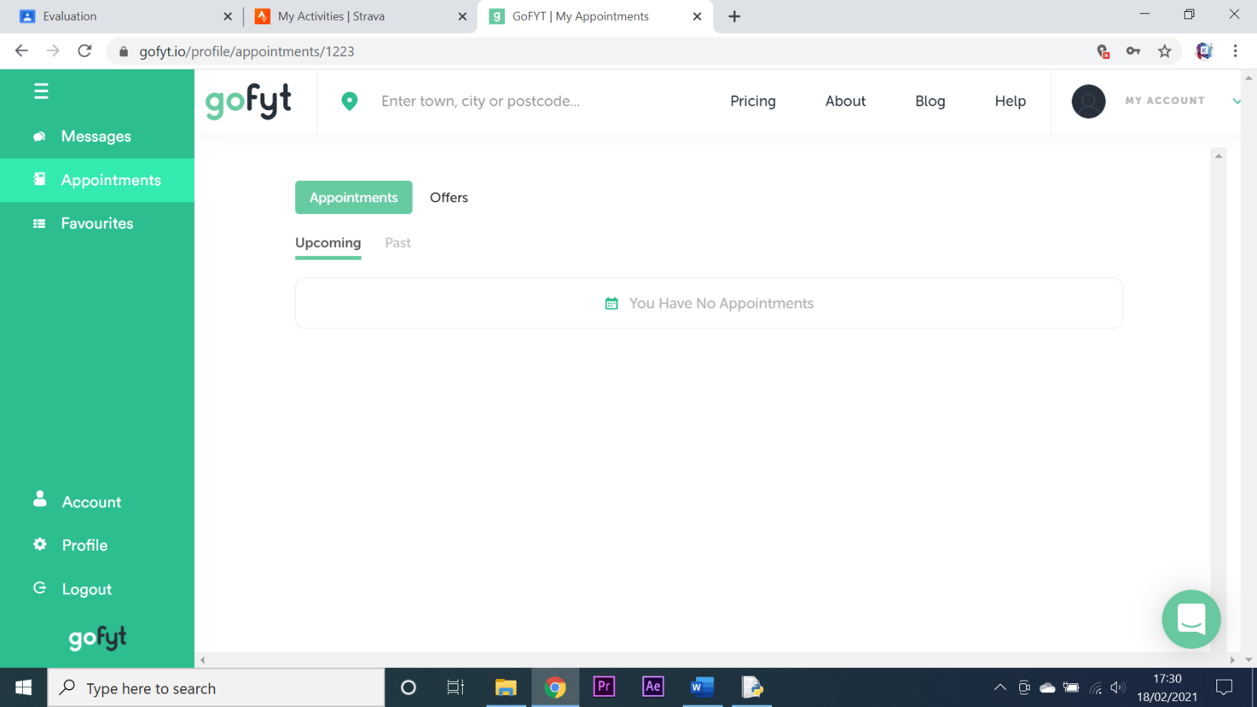

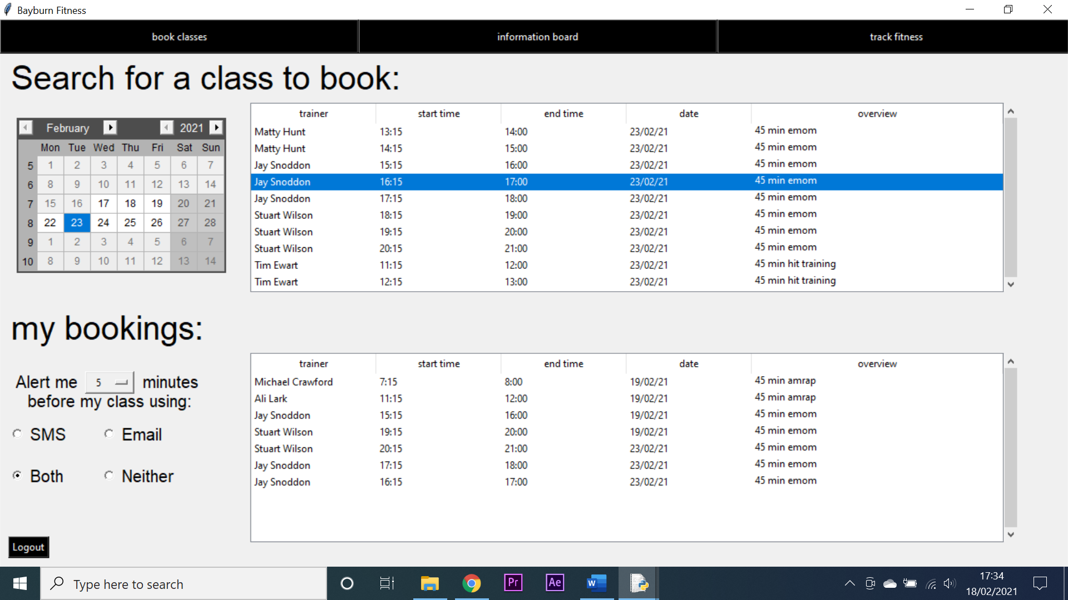Shown above are screenshots which illustrate the class booking system for Gofyt. In contrast my entire booking system is compressed into just one screen as shown below:

**Messaging system** – Gofyt like my system has a built-in messaging feature that allows you to directly communicate with the people you are making an appointment with. Unlike my system however it does not give the ability for a client to be alerted when a message has been sent to them. Gofyt does also allow for the sending of emojis, GIFs and pictures across their messaging system. My system also acts as more of a message board since it only allows managers ant trainers to send messages as opposed to clients. A comparison between Gofyt’s messaging system and mine is shown below:

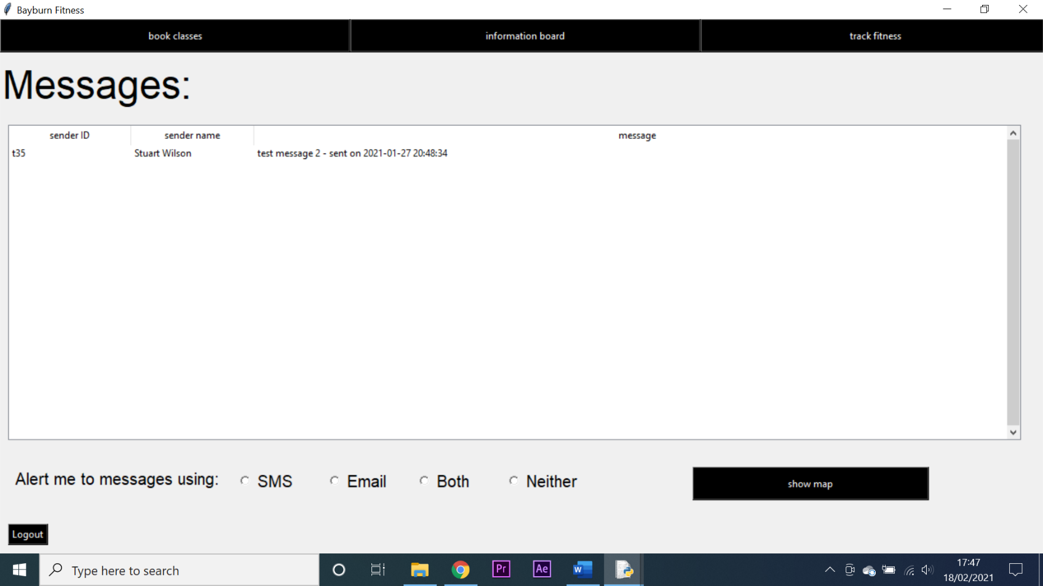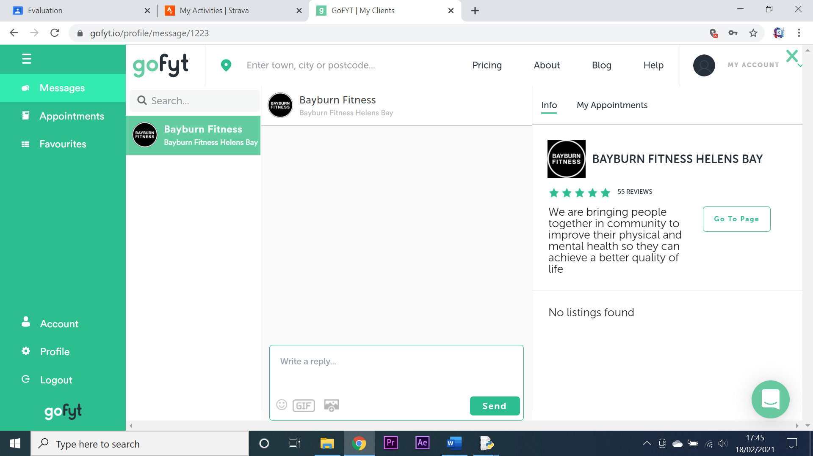

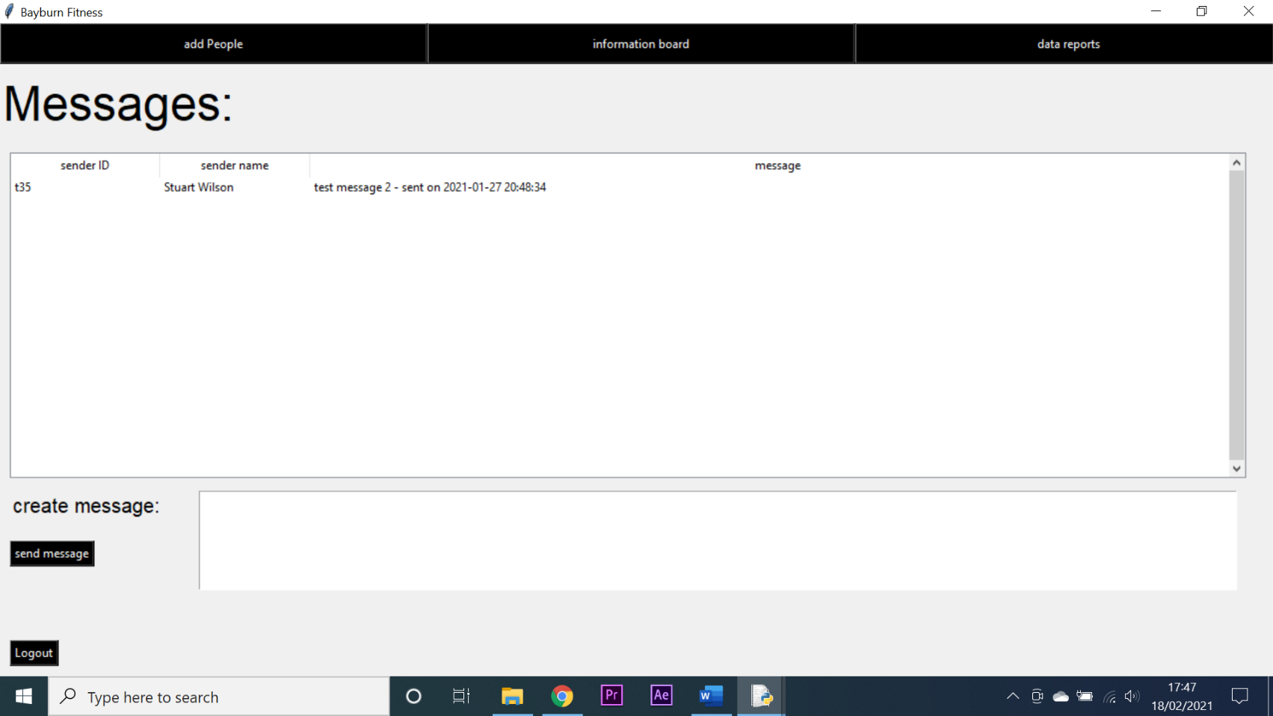

**Fitness tracker** – Strava is the app I will be using to compare my systems fitness tracker to. This is because Strava is renowned as one of the best fitness tracking apps for all sports and integrates well with competitions and maps. Strava also supports connection to phones and fitness devices such as Fitbits and Garmins. My system’s fitness tracker does not support external devices or GPS tracking. Another thing that Strava can do but my system cannot is allow a user to share their recordings as if it were social media. One problem with Strava is that in order to access several of its features you must pay a monthly subscription fee. All of these features would have been great to implement however this would drastically increase the time taken to complete the project and I was unaware of python’s ability to connect to external devices at the time of development. Shown below is a comparison between Strava’s fitness tracking system and mine:

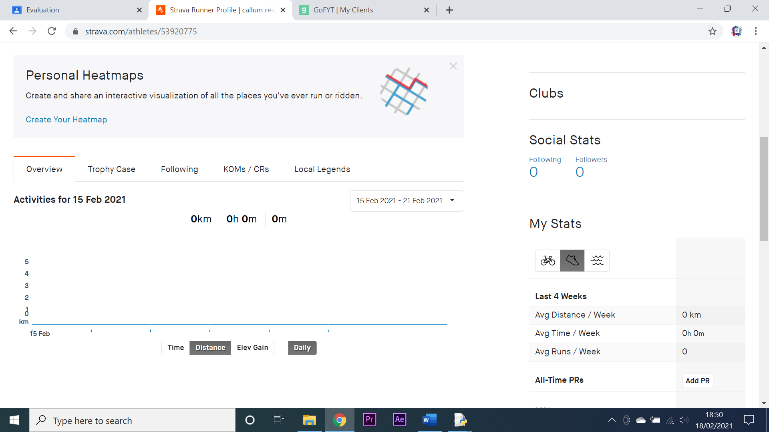

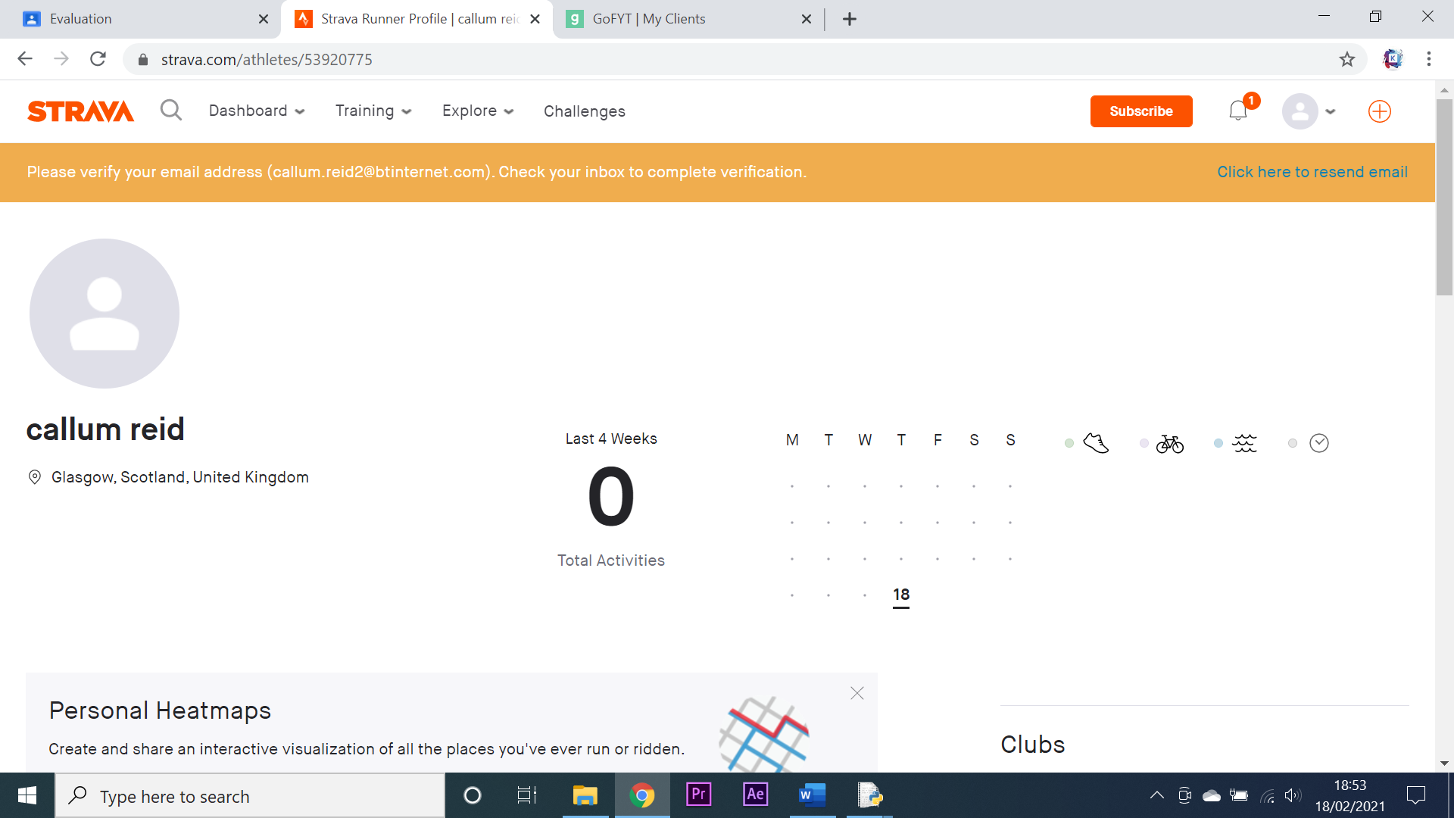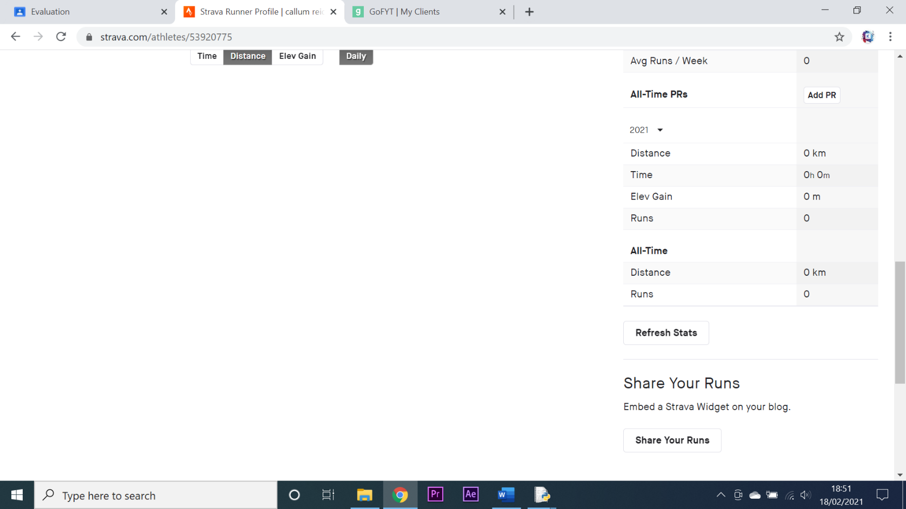

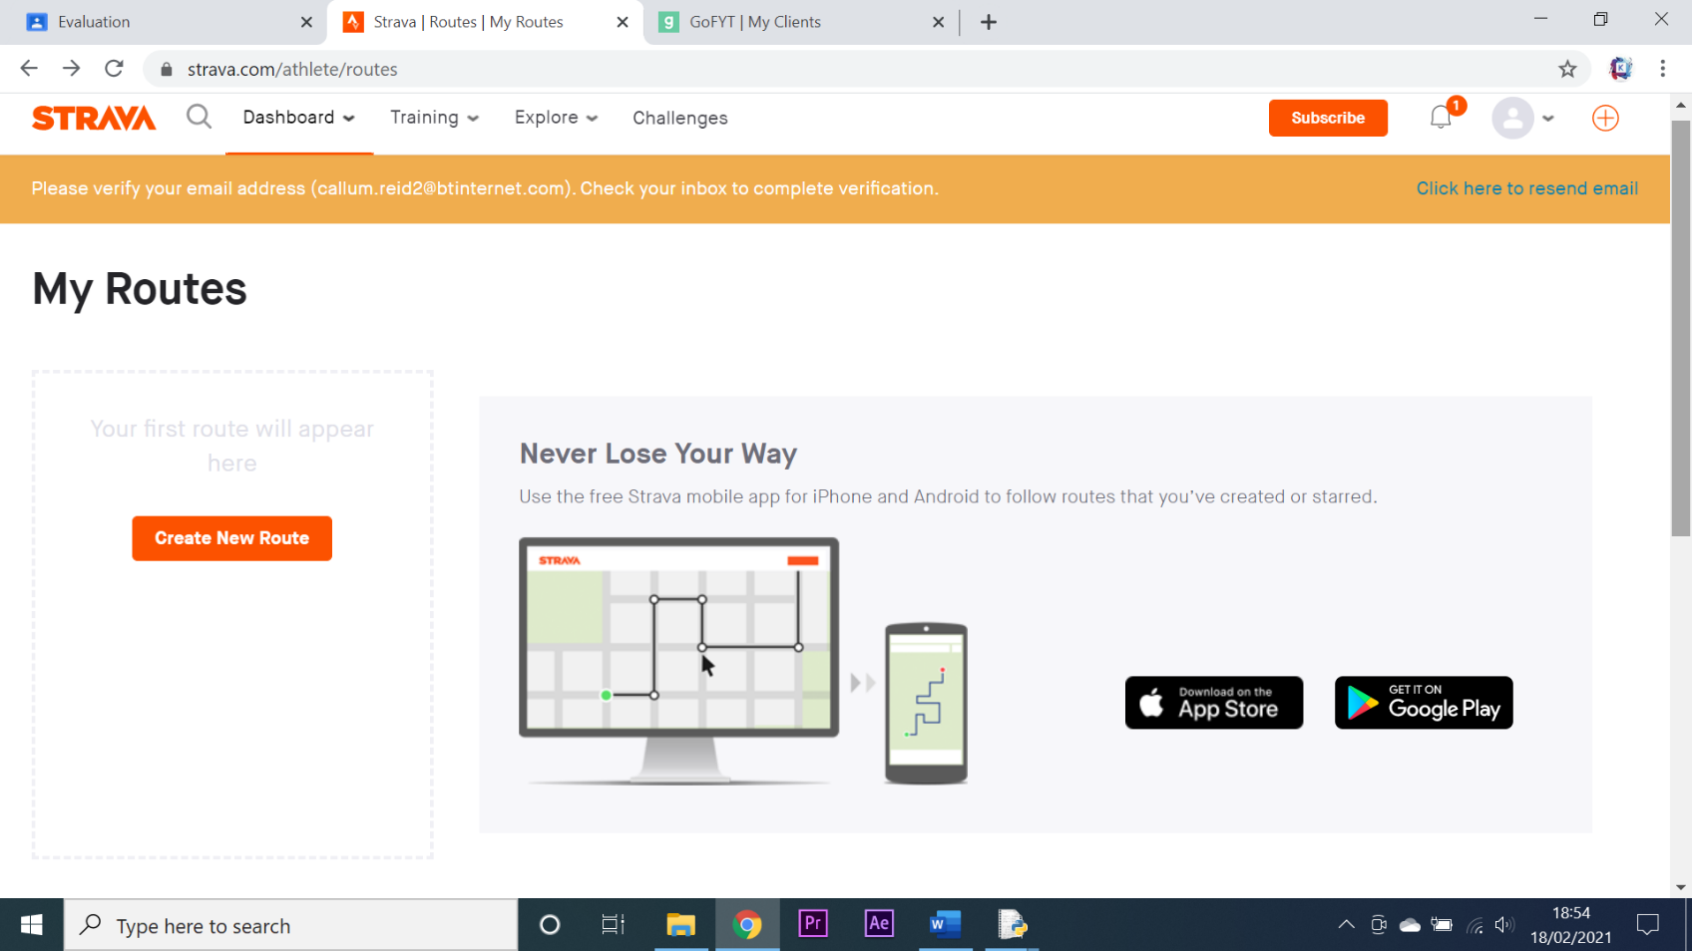

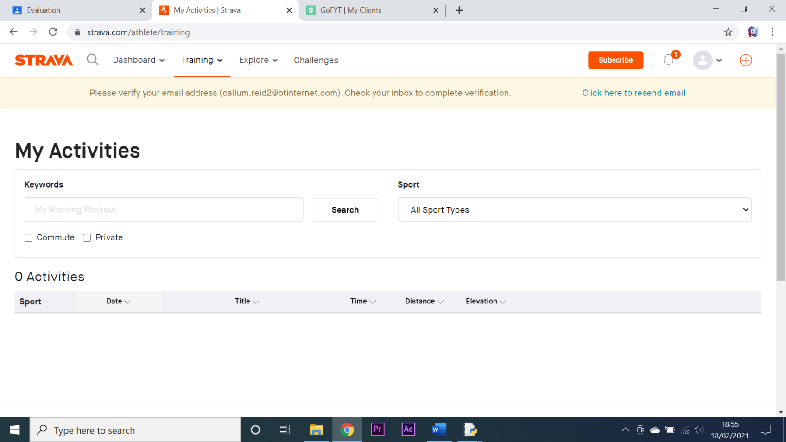

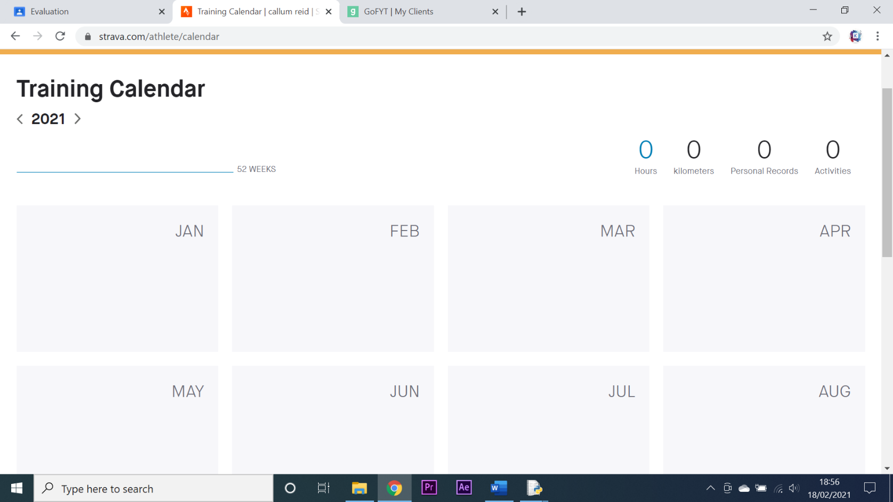

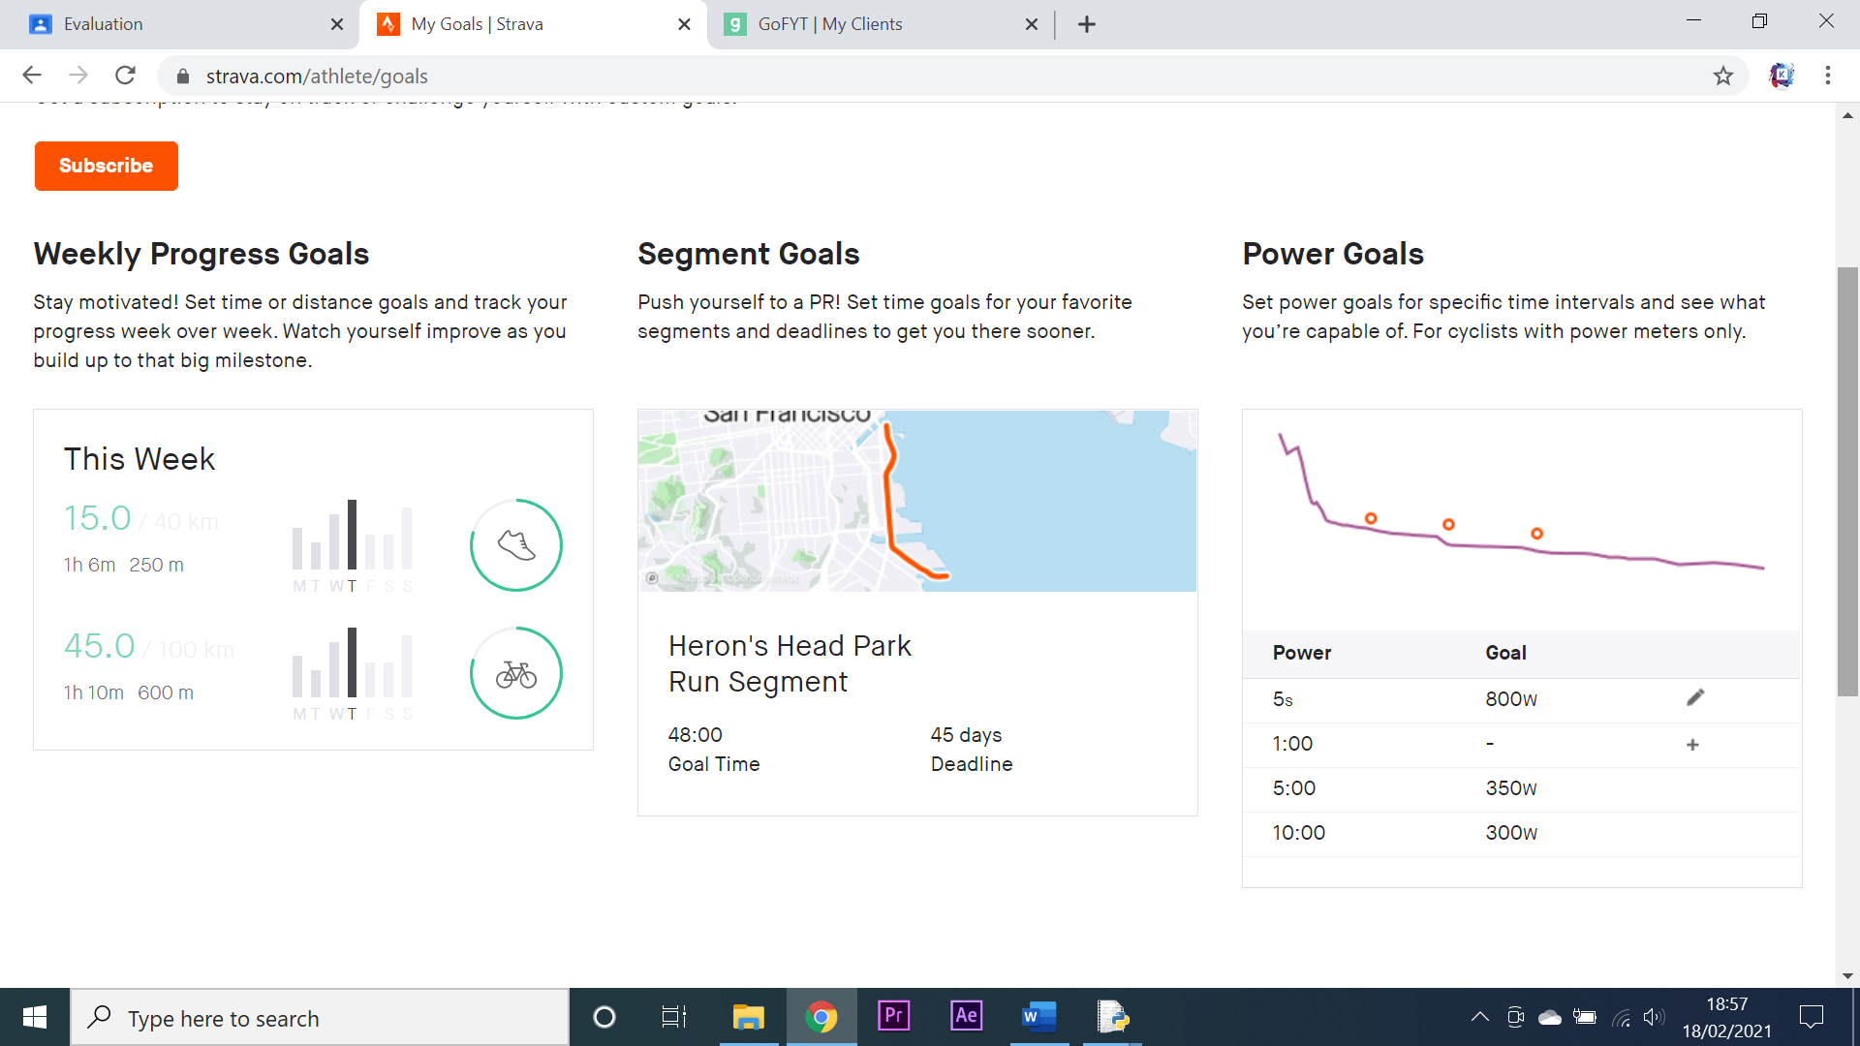

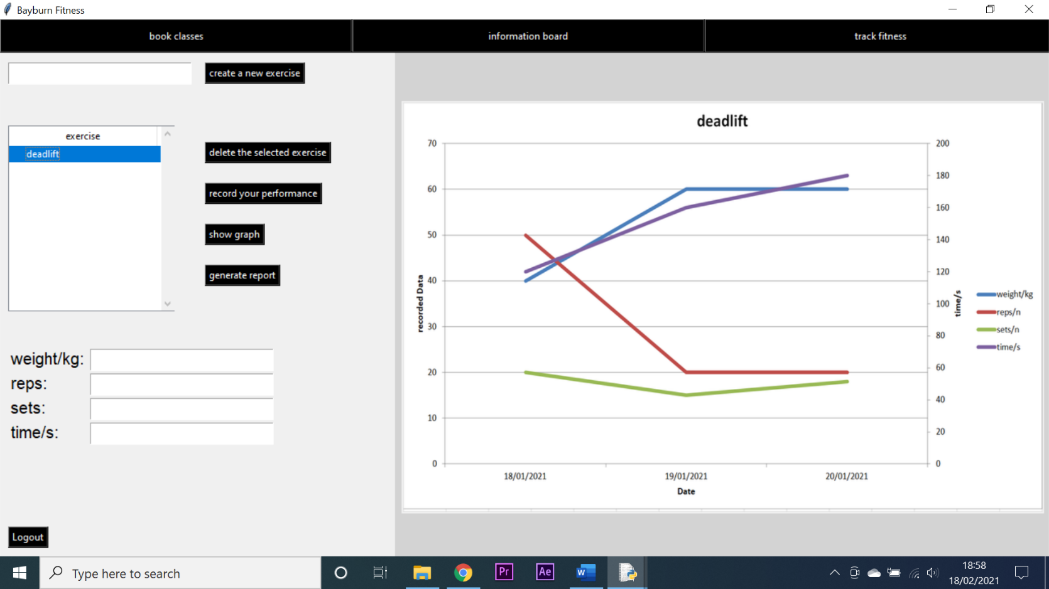

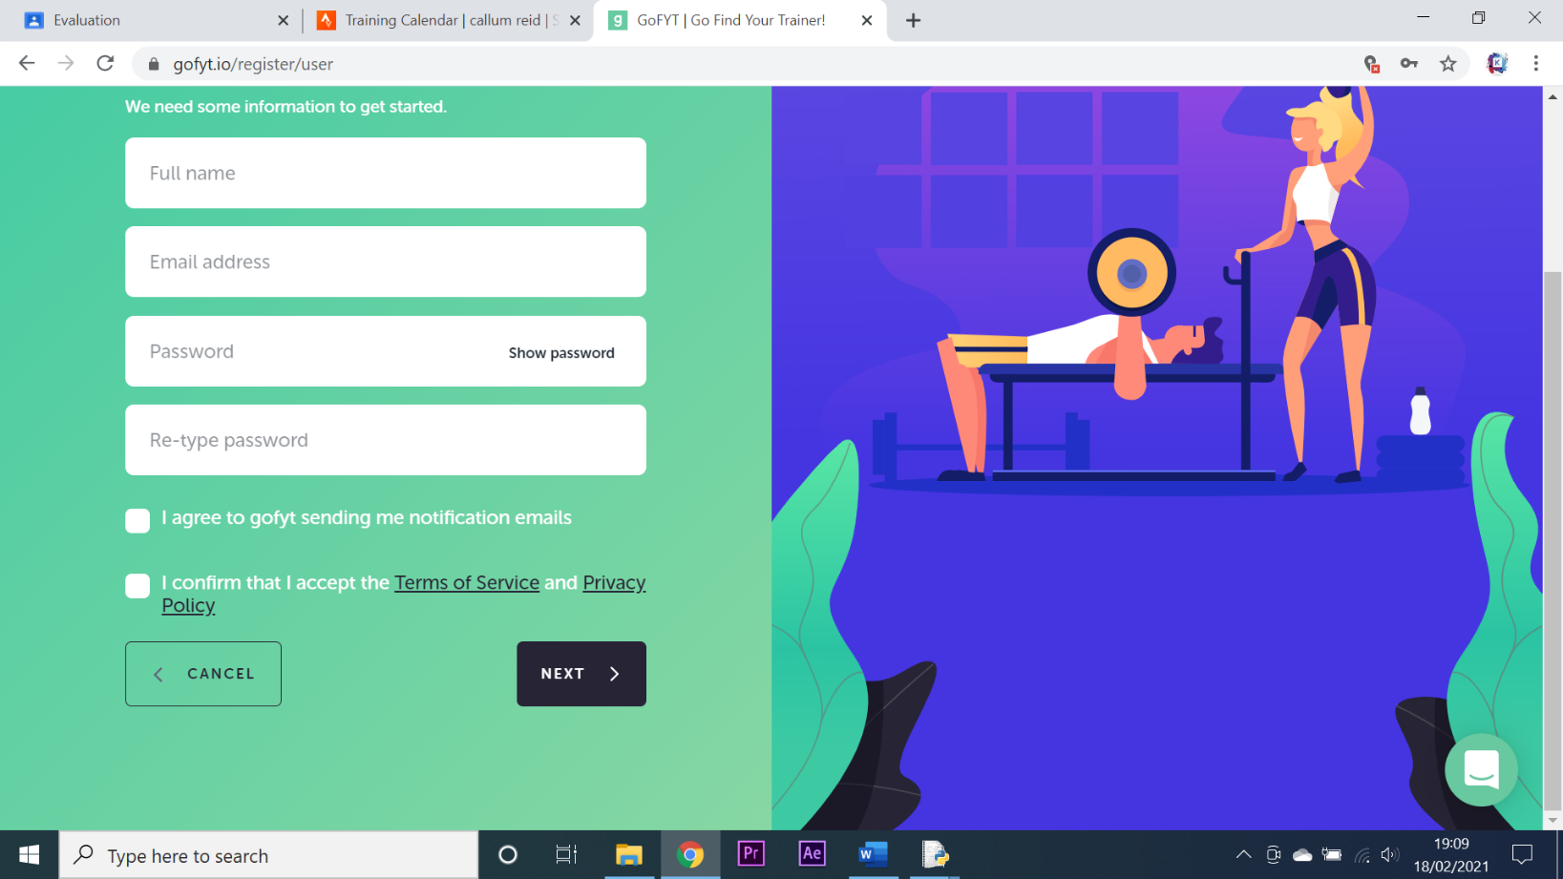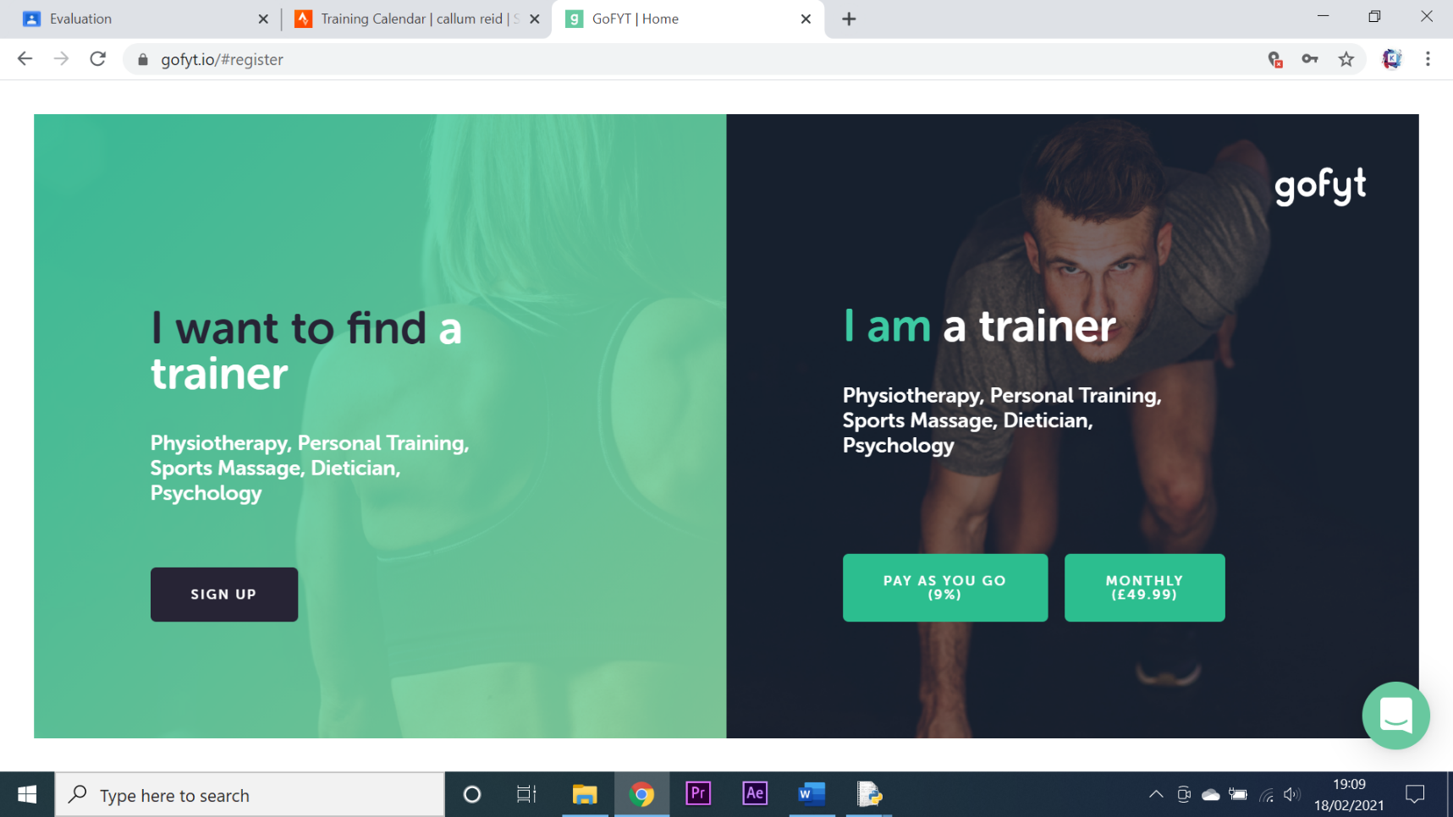**Creating accounts** – My system requires accounts to be created by a manager for clients and trainers. This system is admittedly flawed as it would be more efficient of clients could create their own accounts as is possible using Gofyt and Strava. Shown below are the registering systems for Gofyt and Strava compared to mine:

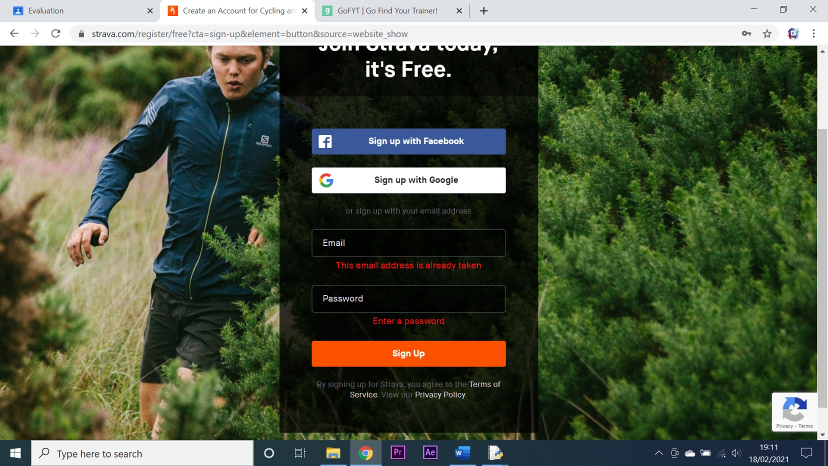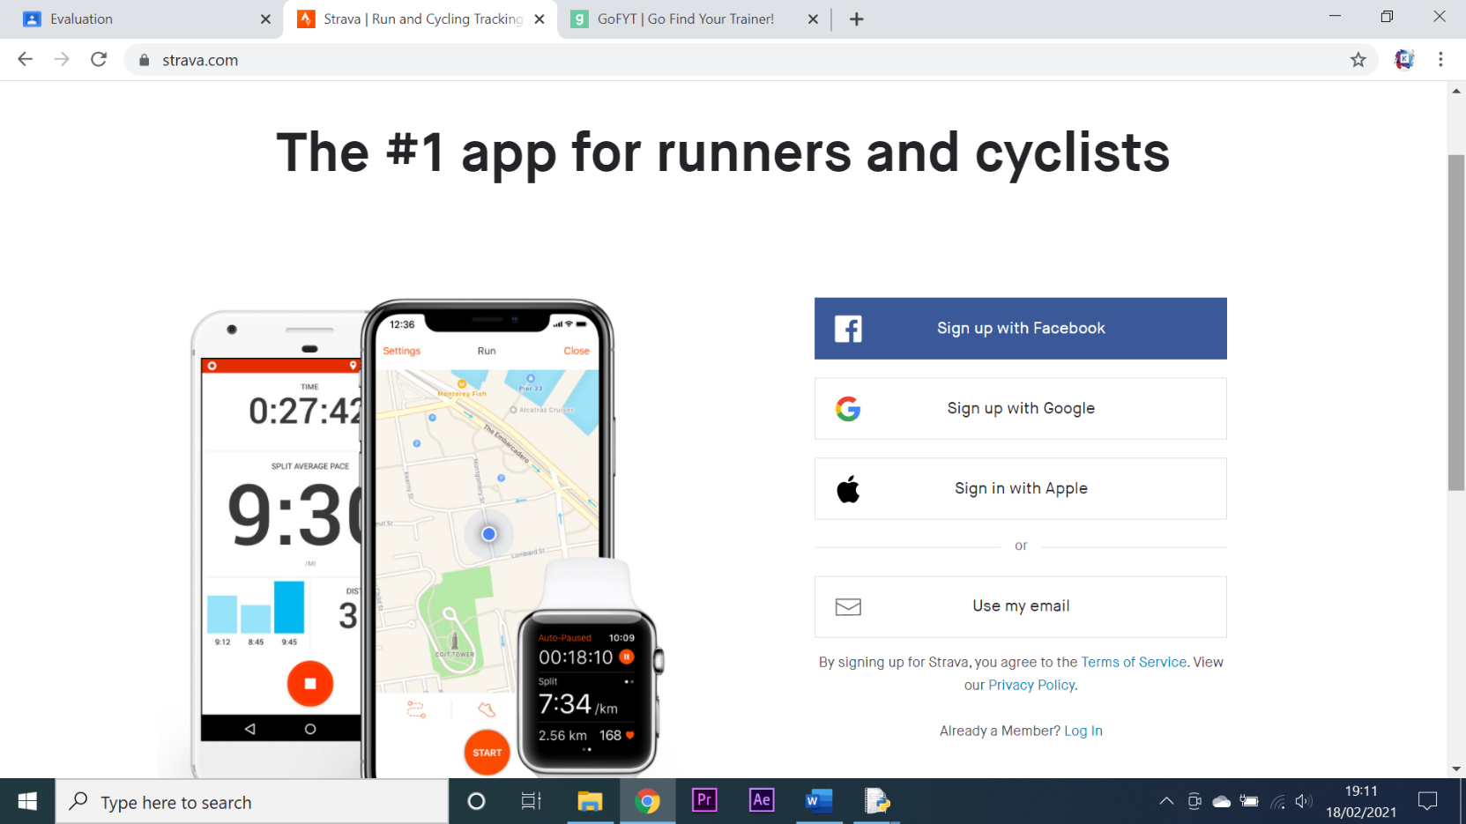

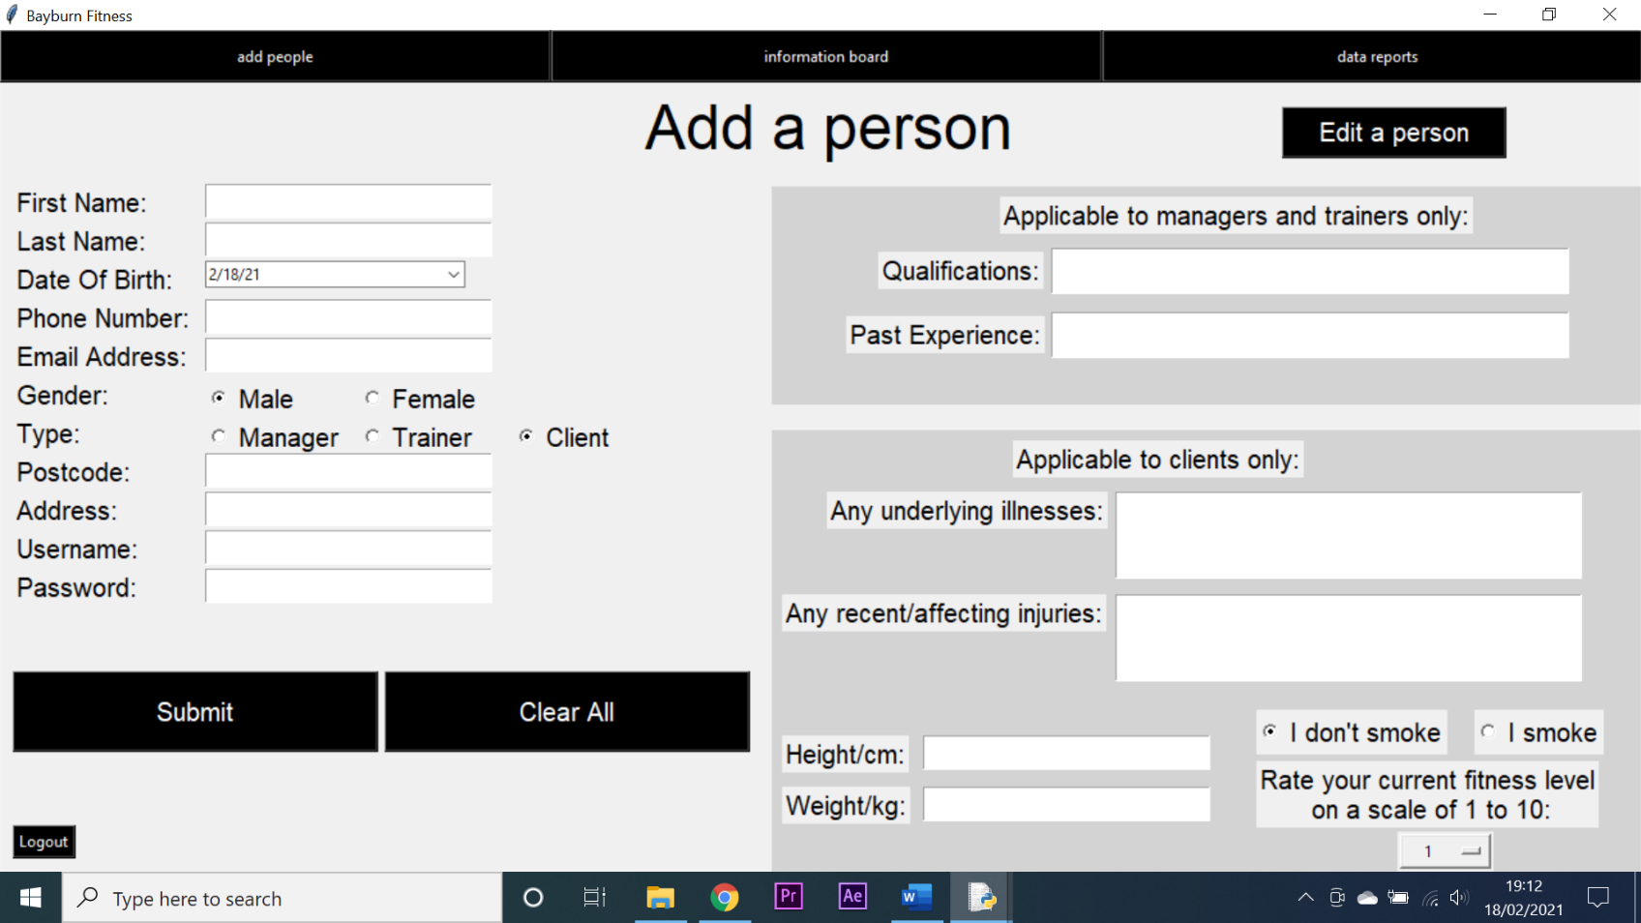

**Conclusion** – I believe that these two systems add upon the functionality of my system extensively however I also believe that I have managed to implement some features that these two have not. For example, my fitness tracker allows for the tracking of individual exercises and my system implements more SMS and email messaging than these applications as well as allowing for the generation of word documents as reports. I was unable to compare the systems on the basis of a trainer or manager as both of these systems require the user to pay in order to access those features. I also think that the graphical user interfaces of the two compared systems are sleeker and more professional than mine. In conclusion I believe that my system combines the functionality of both systems into one system however the functionality is not as extensive. I believe this could have been rectified if I had more time to develop the project as well as knowing the things I know now about modules, databases and general programming knowledge. I also believe the system could benefit from an agile development method as opposed to the waterfall method.

**Evaluating user requirements**

**All stakeholders:**

**Objective: -** create an intuitive GUI through which my system can be navigated.

**Success Criteria: -** all stakeholders are pleased with the system’s GUI and require no external training to use it.

**Success Criteria Met: -** Yes

**Comment: -** N/A

**Objective: -** create a login system that gives each stakeholder their individual levels of access.

**Success Criteria:** **-** all stakeholders can log In and when they do, they have the correct level of access.

**Success Criteria Met: -**

**Comment: -** N/A

**Objective: -** create a system that connects to a database which stores all necessary data.

**Success Criteria:** **-** all data that is recorded or generated by the system is stored in a separate database that communicates with the system.

**Success Criteria Met: -** Yes

**Comment: -** N/A

**Objective: -** create a system that keeps all data belonging to stakeholders secure.

**Success Criteria:** **-** all data that is transferred between the system and the database is encrypted.

**Success Criteria Met: -** No

**Comment: -** I was unable to implement encryption into the system due to the fact that I did not know how to do it at the beginning of production, thus in order to implement encryption I would have had to practically rebuild the entire system from the ground up which would have taken considerable time. This is regrettably an error on my part where I should have implemented encryption from the beginning.

**Objective: -** create a system that keeps human error to a minimum by validating inputs.

**Success Criteria:** **-** all inputs into the system are validated and where possible selection is used over entry.

**Success Criteria Met: -** Yes

**Comment: -** N/A

**Objective: -** create a system that allows for easy remote communication between stakeholders.

**Success Criteria:** **-** all stakeholders confirm that they can easily communicate with each other remotely through the system.

**Success Criteria Met: -** Yes

**Comment: -** N/A

**Objective: -** create a system that improves the overall experience of being a part of Bayburn Fitness.

**Success Criteria:** **-** all stakeholders confirm that their experience in being a part of Bayburn Fitness has been improved by the system.

**Success Criteria Met: -** Yes

**Comment: -** N/A

**Managers:**

**Objective: -** create a system that allows managers to add, edit and delete stakeholders from the system with ease.

**Success Criteria:** **-** the managers confirm that it is easy to add, edit and delete stakeholders.

**Success Criteria Met: -** Yes

**Comment: -** N/A

**Objective: -** create a system that can greatly improve communication between managers and trainers/clients.

**Success Criteria:** **-** all managers have confirmed that communication between them and the trainers/clients has been greatly improved by the system.

**Success Criteria Met: -** Yes

**Comment: -** N/A

**Objective: -** create a system that allows a manager to generate in depth reports on class attendance and who has paid for their classes.

**Success Criteria:** **-** all managers are capable of generating reports which show all relevant information about class bookings and payments in depth.

**Success Criteria Met: -** No

**Comment: -** This criterion has been partially met. The manager is able to generate in depth reports on many aspects of the system however I never implemented a way of tracking who has paid for their classes. However otherwise this criterion has been successfully met.

**Objective: -** create a system that reduces the amount of overall paperwork needed to be done by a manager.

**Success Criteria:** **-** all managers confirm a reduction in paperwork as a result of the new system.

**Success Criteria Met: -** Yes

**Comment: -** N/A

**Objective: -** create a system that allows managers to access the information associated with any individual client or trainer.

**Success Criteria:** **-** all managers confirm that they can easily access data of any individual trainer or client.

**Success Criteria Met: -** Yes

**Comment: -** N/A

**Objective: -** create a system that improves the organisation and availability of data

**Success Criteria: -** all managers confirm that data is organised more efficiently and is readily available.

**Success Criteria Met: -** Yes

**Comment: -** N/A

**Trainers:**

**Objective: -** create a system that allows trainers to create, edit and delete classes with ease.

**Success Criteria:** **-** all trainers confirm that they can easily create, edit and delete classes.

**Success Criteria Met: -** Yes

**Comment: -** N/A

**Objective: -** create a system that allows trainers to communicate easily and remotely with clients and managers.

**Success Criteria:** **-** all trainers confirm that the communication between them and managers/clients has been improved.

**Success Criteria Met: -** Yes

**Comment: -** N/A

**Objective: -** create a system that allows a trainer to view all of the people who have booked into their classes.

**Success Criteria:** **-** all trainers confirm that they can easily see which clients have booked into the classes that they have made.

**Success Criteria Met: -** Yes

**Comment: -** N/A

**Objective: -** create a system that allows a trainer to record the attendance of clients who book into classes.

**Success Criteria:** **-** all trainers confirm that they can easily record which clients out of the ones that booked into a class, actually attended the class.

**Success Criteria Met: -** Yes

**Comment: -** N/A

**Objective: -** create a system that reduces the overall amount of paperwork that has to be done by a trainer.

**Success Criteria:** **-** all trainers confirm that the amount of paperwork that they have had to do has been reduced due to the system.

**Success Criteria Met: -** Yes

**Comment: -** N/A

**Objective: -** create a system that informs the trainer of specific events via email or text.

**Success Criteria:** **-** all trainers confirm that they can receive emails or texts to notify them of events.

**Success Criteria Met: -** No

**Comment: -** This feature was reserved for clients only, whilst trainers can send messages they are not alerted via email or SMS as to when other messages are sent unlike with clients.

**Clients:**

**Objective: -** create a system that allows clients to book into classes that have been created by trainers.

**Success Criteria:** **-** all clients confirm that they are able to book into classes that have been created by trainers.

**Success Criteria Met: -** Yes

**Comment: -** N/A

**Objective: -** create a system that allows clients to easily communicate with managers and trainers.

**Success Criteria:** **-** all clients confirm that they are easily able to remotely communicate with managers and trainers.

**Success Criteria Met: -** Yes

**Comment: -** N/A

**Objective: -** create a system that allows clients to easily track their fitness progress.

**Success Criteria:** **-** all clients confirm that they are able to easily track their fitness progress using the system.

**Success Criteria Met: -** Yes

**Comment: -** N/A

**Objective: -** create a system that contributes to the overall fitness of a client.

**Success Criteria:** **-** all clients confirm that their fitness level has increased since the system was implemented.

**Success Criteria Met: -** Yes

**Comment: -** N/A

**Objective: -** create a system that allows clients to be notified of events via emails and text messages.

**Success Criteria:** **-** all clients confirm that they are able to receive text messages and emails that notify them of current events.

**Success Criteria Met: -** Yes

**Comment: -** N/A

**Objective: -** create a system that allows clients to set targets for their fitness and for these targets to be visualised on the fitness tracker.

**Success Criteria:** **-** all clients confirm that they are able to create fitness targets and that those targets have been visualised on the fitness tracker.

**Success Criteria Met: -** No

**Comment: -** This feature was not implemented in the end. When generating graphs for the fitness tracker I decided to use Excel as I think it looks better than matplotlib and it has better axis scaling. However, when trying to implement a target setting system, the programme took upwards of 120 seconds to create the graph. I thought that this was an unacceptable time to wait for graph creation and so I scrapped the system.

**System evaluation**

In this section I will identify strengths of my system which I could implement in future systems as well as identify weakness and then use those weaknesses to identify possible improvements which could be made to the system in future.

**Strengths**

* The system is fully functional.
* The system meets the majority of user requirements fully.
* The system is easy to navigate.
* The system does not crash or slow down during use.
* The system includes email messaging.
* The system includes SMS messaging.
* The system includes graph generation.
* The system includes report generating and saving via word documents.
* The system is intuitive to use.

**Weaknesses**

* The system did not meet 4 of the success criteria fully.
* The system does not encrypt the data stored in the database.
* The system is currently only application based and not web based.
* The system does not include a built-in payment system.
* The system requires managers to add clients and trainers.

**Improvements**

* Encrypt all data stored in the database.
* Use PayPal API to implement payment system.
* Implement system to connect to Garmin.
* Rework fitness tracker to implement goal setting.
* Rework system to allow clients and trainers to add themselves to the system.
* Port the system to make it web based.

**Person development**

This section will highlight the different things I have learned when developing this system.

**Programming ability** – throughout the production and development of this system I have been able to hone my skills as a programmer and find more efficient solutions to intricate and difficult problems. I have also become more acquainted with python modules and although I was not able to implement all of them, I am now able to use modules to connect python to a Garmin, PayPal and Excel. I however still have not tried much in the way of object-oriented programming or programming in other languages.

**Database management** – I believe that database management was a hard point in development for me as I think I could have made better use of data types, key fields and foreign keys to ensure that database management remained easy throughout the project. I was however able to learn these skills later in development and am now far more confident in database management.

**Time management** – Throughout the development of this system I have had to meet deadlines and keep to a schedule in order to ensure the finale product was delivered on time and that I had enough time to bug fix. This allowed me to develop my time management skills and increased my ability to manage my workflow.

**Changes of approach for future projects**

In this section I will highlight some changes I would make to my approach in the production of future project.

**Agile development** – In future projects I would most likely use the agile development strategy as apposed to waterfall as it focusses more emphasis on the coding aspect of development as apposed to the documents. I believe that this would allow me to spend more time developing features and functionality into my system as opposed to writing up on these features and functionality. It would also allow me to interact more with the client of the product and develop the system in a way that best suited them.

**MySQL feature utilisation** – In future projects involving a database I would place more emphasis on using the vast array of features that the MySQL database management system provides. MySQL has many features such as key fields, foreign keys and setting columns as specific data types, I feel that during this project I underutilised these features and that if I utilised them properly, I could have streamlined the production process.

**Procedural programming** – for this project I used primarily procedural programming, however I do believe that there were many instances in which I could have created separate functions and called them at a later date to decrease the complexity and abundance of overused code. For example I think I could have created several functions for database management at the beginning of the project and this would have reduced the amount of times I had to repeat code.